SURVIVAL OR EXTINCTION

by
KEVIN MUGUR GALALAE

PART TWENTY
FREE THE TRUTH
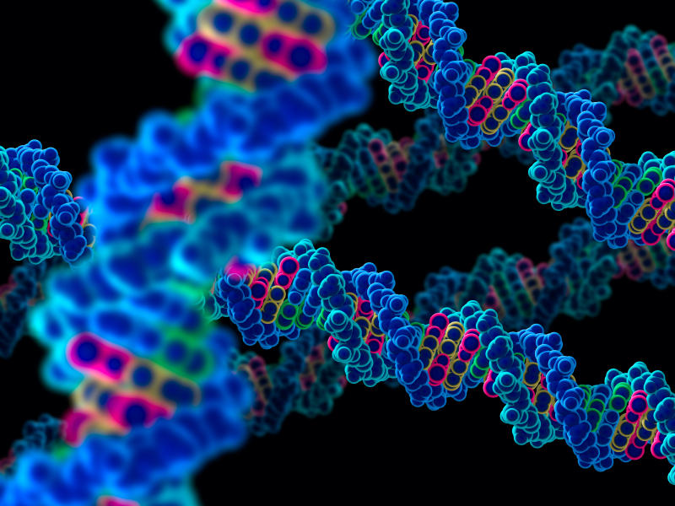

(PART ONE: LIFE OR DEATH; PART TWO: FOLLOW THE MONEY; PART THREE: NEED NOT GREED; PART FOUR: TAMING THE WOLVES; PART FIVE: DISCARD ME NOT; PART SIX: HEAD AND HAND; PART SEVEN: POWER OF MONEY; PART EIGHT: BURDEN OF RESPONSIBILITY; PART NINE: CONCEAL AND DECEIVE; PART TEN: CRISIS OF LEADERSHIP; PART ELEVEN: COUNTRIES ARE PRISONS; PART TWELVE: PEACE WITHOUT POISON; PART THIRTEEN: INVOLVED IN MANKIND; PART FOURTEEN: INTO THE WILD; PART FIFTEEN: MAN OR NATURE; PART SIXTEEN: SLAYING THE BEAST; PART SEVENTEEN: GEEKS, ZEALOTS, BILLIONAIRES; PART EIGHTEEN: THE NEW MORALITY; PART NINETEEN: LIONS AND LAMBS)

There are several factors, in addition to the inertia that characterizes every society, that stand in the way of the much-needed change we need and that keep the status quo despite its obvious inadequacy to serve the interests of the world’s seven billion people, the earth and of future generations.
First, those who champion absolutism over democracy have once again reared their ugly heads, this time globally and not just nationally, and have enlisted the help of pure evil to entrench their power and elevate their status in society. Throughout the ages they have justified their privileged and mostly parasitical existence by insisting that men are fundamentally evil and need to be controlled with an iron fist if they are not to kill each other. This Hobbesian view of the world is sponsored by monarchs, tyrants and militarists the world over and reflects not only the dark hearts and minds as well as the personal interests of those who disseminate it but also their lack of vision and of true leadership qualities.
The Anglo-American coalition in control of the world since 1945 has been gradually corroded by this distorted view of mankind, having been infected with it by the British monarchy and aristocracy, which is the global seat of this mentality, as have many heads of state and government throughout the world As a result, this Anglo-American coalition has designed an international system that treats every human being as an enemy or a potential enemy of the state. The militarization of the United States, and through it of the world, is the primary example of how far this sick mentality can be taken and how disastrous it can be.
Unless and until this distorted and perverse view of man’s nature as fundamentally evil is discredited and discarded once and for all the world will not be able to reach out to the enlightened and healthy view of man as a fundamentally good being and design the social construct accordingly.
If you see man as fundamentally evil you will treat him badly and he will behave badly. If you see man as fundamentally good you will treat him well and he will behave well. Man, of course, is a contradiction of virtues and vices but only an enlightened view of him will make enlightened human beings. This is the philosophical imprisonment that we must overcome. The OM Principles embody the enlightened view of man and their application will enable true human progress and relegate our dependence on science and technology to secondary status giving precedence to the evolution of man and not that of his machines.
Second, man is a creature of habits. He will always prefer that which he knows to that which he does not know. But refusing to change our ways, our operational premises, our system and our institutions is no longer a luxury we can afford. Maintaining the status quo has led us to social collapse and will spell the end of our civilization. What this boils down to is survival or extinction. The globalization and depopulation prerogatives, which are not choices but requirements since they are not preferences but inescapable imperatives, cannot be accomplished without fundamentally altering our social, economic and political system and the sooner we get on with it the better. The OM Principles show how and why we must change.
It is clear that the end does not justify the means, especially when the means will not reach the desired end. The covert methods of depopulation employed now are diabolical and counterproductive. Yes, they depopulate the earth but those few remaining will be but shadows of their former selves and far inferior to their forefathers: dumber, weaker, crazier and sicklier; a degraded lot fit only for the zoo. Equally, the current coerced methods of globalization will eradicate hunger but only by plunging us all into poverty and taking the environment to the brink and perhaps beyond, so why bother making the sacrifice.
This is the time to abandon our bad habits, our dated ideologies, our expired dogmas and doctrines, and our loyalty to inept hierarchies of power and the profit motive. We can no longer continue to drive a horse and buggy on the autobahn of history, no more than we can afford to ride a bullet train into the abyss of space.
Third, overpopulation is a biological problem but it is not an illness. We have a population problem not because our reproductive systems have malfunctioned but because they are working normally, as they should. Therefore, seeking a biological solution cannot work since such a solution would mean that our normal biology is to be rendered abnormal. We cannot reestablish the lost balance of life and death, central to the stable populations dictated by natural harmony, by subverting our reproductive systems. No less then we can do it by shortening our lifespans. It can only be done by exercising self-restraint on the reproductive front as a matter of individual responsibility towards society, the planet and future generations, which is why population control needs to be legislated and enshrined in our cultural values and not just legal norms.
This demands a new morality that enlarges our existing morality by two new dimensions: the wellbeing of future generations, and the wellbeing of the planet. These two new dimensions must be on equal footing with our own wellbeing, which is the only dimension on which our current morality operates.
Fourth, we have lacked a unified social theory to move us forward. But that is no longer the case. The OM Principles provide such a unified social theory and the sooner we adopt them the sooner we can stop groping in the dark and pushing each other off the ledge, which is the only “solution” our bright leaders have come up with so far. That such a unified social theory was not provided by the army of professionals who get paid for this purpose, or by any of the politicians who are supposed to lead us, but rather by me, a complete outsider, should not deter decision makers from adopting it because their vanities stand in the way.
The demographic transition and the eradication of poverty cannot be accomplished with the existing political and economic structures, not even by turning the institutions of state upside down and the rule of law and democracy inside out, since the existing political and economic structures are the main sources of these imbalances.
Fifth, to return the world to sanity, concerned and caring citizens must concentrate on dismantling the matrix of control and replacing it with a matrix of safety. To do this everyone must realize that the matrix of control is the depopulation/globalization axis. So instead of attacking and demonstrating against single issues – which is a complete waste of time because all problems derive from the folly of trying to accomplish the depopulation and globalization objectives by strengthening rather than changing the economic system and political structures that have brought us to this desperate state – people must focus on pushing for structural reform as prescribed in this book and as demanded by the material and environmental predicament we are in.
To save humankind from destroying itself through overpopulation, overconsumption and ignorance requires radically changing the system that has brought us to this situation, not further perverting the existing system so its institutions and organizations are more powerful and more corrupt and more unjust than ever before so they can be used to wage a silent war on us and thus fulfill the opposite function they were set up to fulfill, namely harm rather than promote our wellbeing. If they could not solve our problems when they were honestly meant to do so how could they be expected to solve our problems when they are dishonestly meant to do so?

When our excessive numbers and our voracious appetites for the planet’s resources exceed the limits of nature and threaten all life on earth, averting disaster dictates that we reverse our numbers and shrink our consumption. But this cannot and must not be accomplished by turning man’s institutions against man but by educating and empowering man to limit his offspring and reduce his expectations.

This was recognized from the very beginning by intelligent, foresighted and caring men and women but their few numbers has prevented them from being able to persuade the indifferent masses and religious traditionalists so that each and every individual checks his or her own reproduction and desires. And their numerical inferiority has forced them to proceed in secret and by deception, by manipulating the existing system, promoting man’s ugly traits, playing on his fears and exacerbating the lines of division so as to turn man against man. But in so doing, the men and women who in their intent are the most forward-looking, intelligent and compassionate among us have in practice become the most corrupt, criminal and cruel among us. In pursuing the ultimate good in a vacuum of interest and a sea of ignorance they have become the ultimate source of evil.

But if they back down there is nothing and no one to prevent our self-destruction. Therefore, we the people, whose indifference and ignorance stand in the way of our own empowerment must open our eyes and our hearts to comprehend the we are obstacles to progress and that only we can vanquish evil from this world by assuming responsibility for the state of the world.

We cannot blame the few, who have tried to fight our ignorance and indifference by all available means, for the dire state of the world and who for seven decades have been compensating for our lack of understanding and have waited for us to grow up. We must be honest and recognize that our ignorance and indifference are the main reasons for the dire state of our world and that until such time as we all renounce indifference and dispel ignorance we will continue to be the primary source of our own misery and the ultimate cause of our own demise. Only we can empower you, our leaders, to be good again as soon as you cut our chains.

By the same token, you cannot blame us, the people, for being ignorant and indifferent when for nearly seven decades you have lied to us and deceived us to manipulate us into doing what is necessary and in so doing you have done the unnecessary and have chosen the convenient way forward instead of choosing the right way forward. You must be honest and recognize that your failure to speak the truth and to defend the truth is the cause of our ignorance and that your monopoly of power is the cause of our indifference and that until such time as you renounce power and lies you will continue to be the primary source of the world’s misery and the ultimate cause of mankind’s demise. Only you can free the truth and empower us to cut your chains.

You keep us prisoners to indifference and ignorance and we keep you prisoners to lies and deception. And in this state of mutual imprisonment neither of us has the power to change the world before we destroy it. In this state of mutual imprisonment only our assured mutual destruction is certain.

To free us from indifference and ignorance all you have to do is free the truth. To free you from lies and deception all we have to do is hear the truth.

